

K. J. Somaiya College of Engineering, Mumbai-77
(A Constituent College of Somaiya Vidyavihar University)

Batch:E-2 Roll No.: 16010123325
Experiment / assignment / tutorial No. 2

Title: Design of EER diagram and Mapping to Relational Model
Objective: To Design an EER diagram and to apply mapping techniques to map ER and EER diagram to its equivalent relational model.

Expected Outcome of Experiment:
CO1:Comprehend the Characteristics of Relational Database Management Systems.
CO2: Create Relational Database Designs Based on Entity-Relationship Models.
CO

Books/ Journals/ Websites referred:
- G. K. Gupta :”Database Management Systems”, McGraw – Hill
- Korth, Slberchatz, Sudarshan : “Database Systems Concept”, 6th Edition , McGraw Hill
- Elmasri and Navathe, “Fundamentals of Database Systems”, 5thEdition, PEARSON Education.

Dia Software: A software to Design ER Model

Dia is one of the convenient open source tool which runs on multiple platforms including Linux, Windows and MacOS.Dia has a number of "sheets" each of which includes diagram objects for different modeling tools, such as UML, ER diagrams, flowcharts, etc.

Pre Lab/ Prior Concepts:

The ER data model was developed to facilitate the database design by allowing specification of an enterprise schema that represents the overall logical structure of the database. The ER model is one of the several data models. The semantic aspect of the model lies in its representation of the meaning of the data. The ER model is very useful many database design tools drawn on concepts from the ER model. The ER model employs 3 basic notations: entity set, relationship set and attributes.

Extended Entity Relationship Diagram:
The EER model includes all of the concepts introduced by the ER model. Additionally it includes the concepts of a subclass and superclass (Is-a), along with the concepts of specialization and generalization. Furthermore, it introduces the concept of a union type or category, which is used to represent a collection of objects that is the union of objects of different entity types. EER model also includes EER diagrams that are conceptual models that accurately represent the requirements of complex databases.

Example Case Study: List the data requirements for the database of the company which keeps track of the company employee, department and projects. The database designers provide the following description

Procedure for doing the EER diagram experiment

EER stands for Enhanced ER or Extended ER
EER Model Concepts
Includes all modeling concepts of basic ER
Additional concepts:
- subclasses/superclasses
- specialization/generalization
- categories (UNION types)
- attribute and relationship inheritance
These are fundamental to conceptual modeling
The additional EER concepts are used to model applications more completely and more accurately
EER includes some object-oriented concepts, such as inheritance

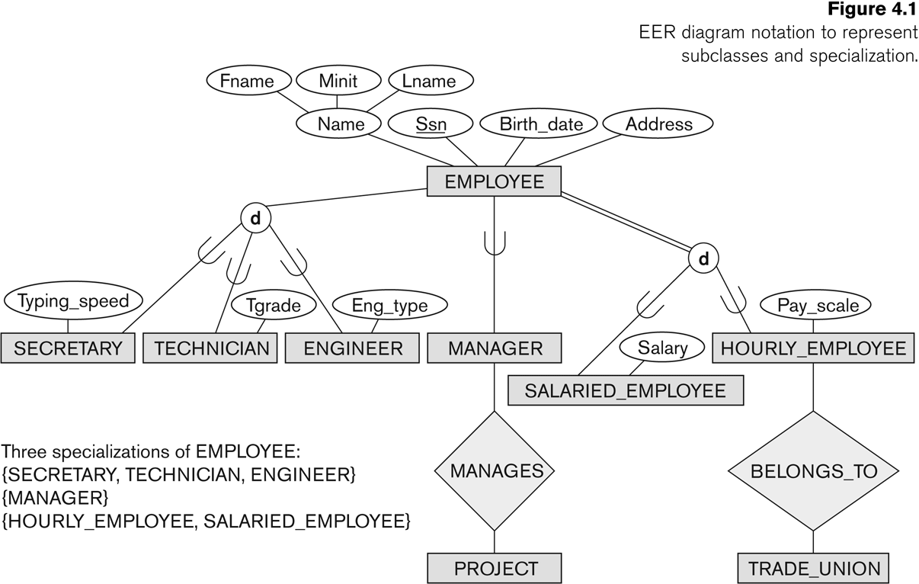

Generalization

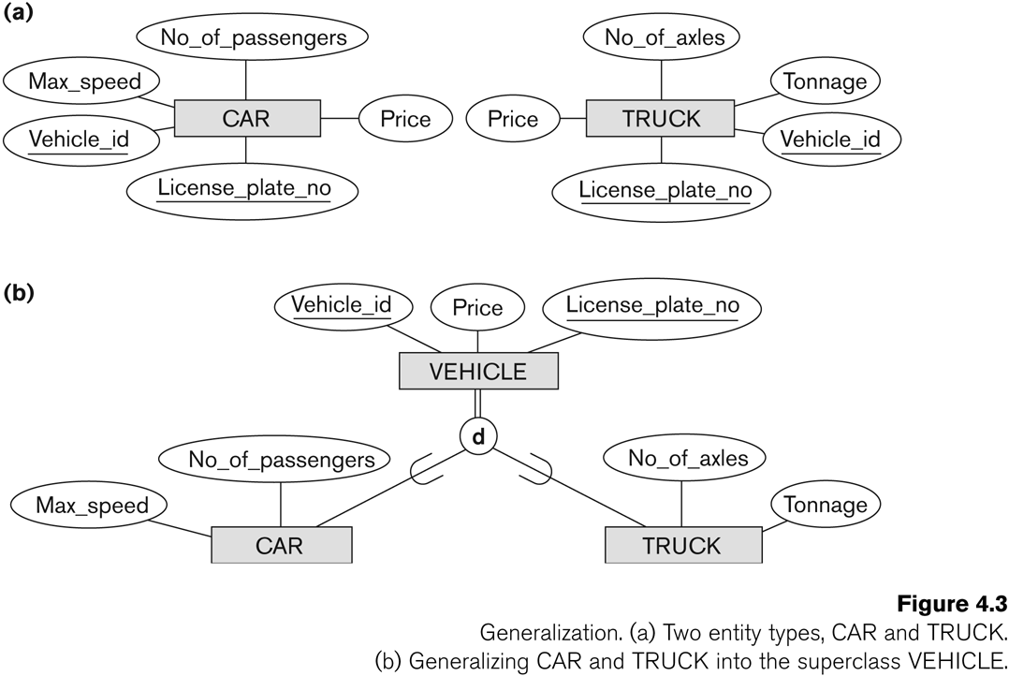
©

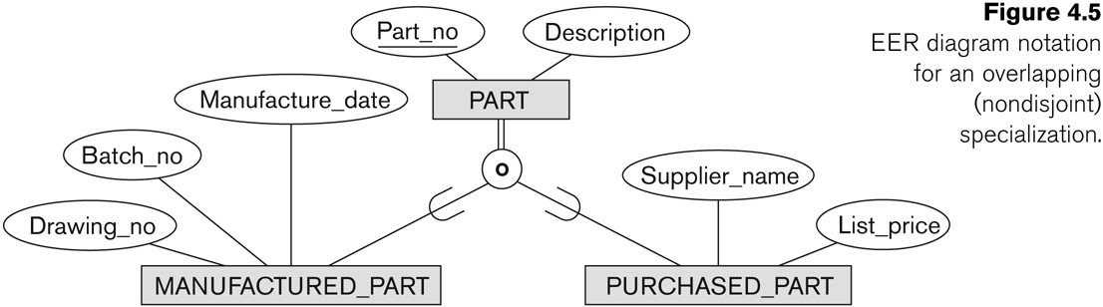

C: Categories and Union
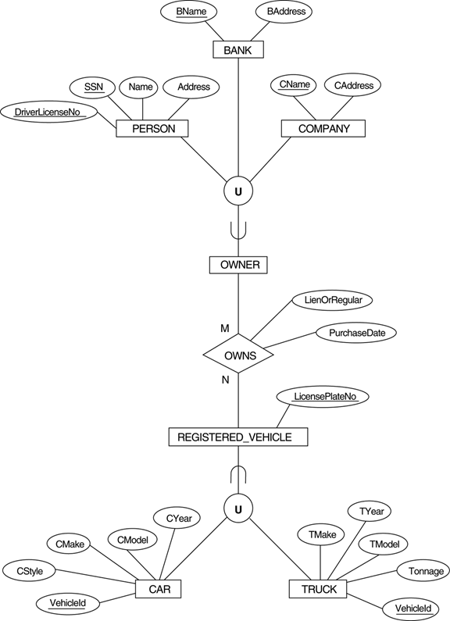

Relational Model:
Relational Model represents the database as a collection of relations. Relational model can be thought of as table of values, each row in the table represents collection of related data values. In the relational model, each row in the table represents the fact that corresponds real world entity or relationship. The table name and column name are used to interpret the meanings of the values in each row. In formal relational model terminology, a row is called tuple, a column header is called an attribute, and table is called a relation. The data type describing the types of values that can appear in each column is represented by a domain of possible values. Thus Relation is set of tuples.

Procedure for doing the Relation Model (ER to Relational Mapping)
- Mapping of Regular Entity
  - For each regular (strong) entity type in the ER schema, create a relation R that includes all the simple attributes of E.
  - Choose one of the key attributes of E as the primary key for the relation
- Mapping of Weak Entity
  - For each weak entity type W in the ER schema with owner entity type E, create a relation R and include all attributes of the weak entity as attributes of the new relation R.
  - Then, include the primary key of the owner entity as foreign key attributes of R
  - The primary key of R is the combination of the primary key(s) of the owner(s) and the partial key of the weak entity type W, if any.
- Mapping of Binary 1:1 Relationship Types
  - For each 1:1 relationship type identify the entities participating in the relationship. There are two possible approaches below:
  - a) Foreign Key approach:
Choose one of the relations and include a foreign key in one relation (S) which is the primary key of the other relation (T). It is better to choose an entity type with total participation in the relationship in the role of S.
  - b) Merged relation option:
An alternate mapping of a 1:1 relationship type is possible by merging the two entity types and the relationship into a single relation. This may be appropriate when both participations are total.
- Mapping of Binary 1:N Relationship Types
  - For each regular 1:N relationship type R, identify the relation S, which is the entity on the N-side of the relationship.
  - Include as foreign key in S the primary key of the relation which is on the 1 side of the relationship
  - Include any simple attributes of the 1:N relation type as attributes of S.
- Mapping of Binary M:N Relationship Types
  - For each M:N relationship type, create a new relation S to represent the relationship
  - Include as foreign key attributes in S the primary keys of the entities on each side of the relationship; the combination of the two primary keys will form the primary key of S
- Also include any simple attributes of the M:N relationship type as attributes of S.
- Mapping of Multivalued Attributes.
  - For each multivalued attribute A, create a new relation. This relation will include an attribute corresponding to the multi-valued attribute, plus the primary key attribute of the relation that has the multi-valued attribute, K
  - The primary key attribute of the relation is the foreign key representing the relationship between the entity and the multi-valued relation
  - The primary key of R is the combination of A and K
- Mapping of N-ary Relationship Types
  - For each n-ary relationship type R, where n>2, create a new relation S to represent the relationship.
  - Include as foreign key attributes in S the primary keys of the relations that represent the participating entities
  - Also include any simple attributes of the n-ary relationship type as attributes of S
- Options for Mapping Specialization or Generalization
- Convert each specialization with m subclasses {S₁, S₂,….,S_{m}} and generalized superclass C, where the attributes of C are {k,a₁,…a_{n}} and k is the (primary) key, into relational schemas using one of the four following options:
Option 8A: Multiple relations-Superclass and subclasses.
Option 8B: Multiple relations-Subclass relations only.
Option 8C: Single relation with one type attribute.
Option 8D: Single relation with multiple type attributes.

Company Database EER model
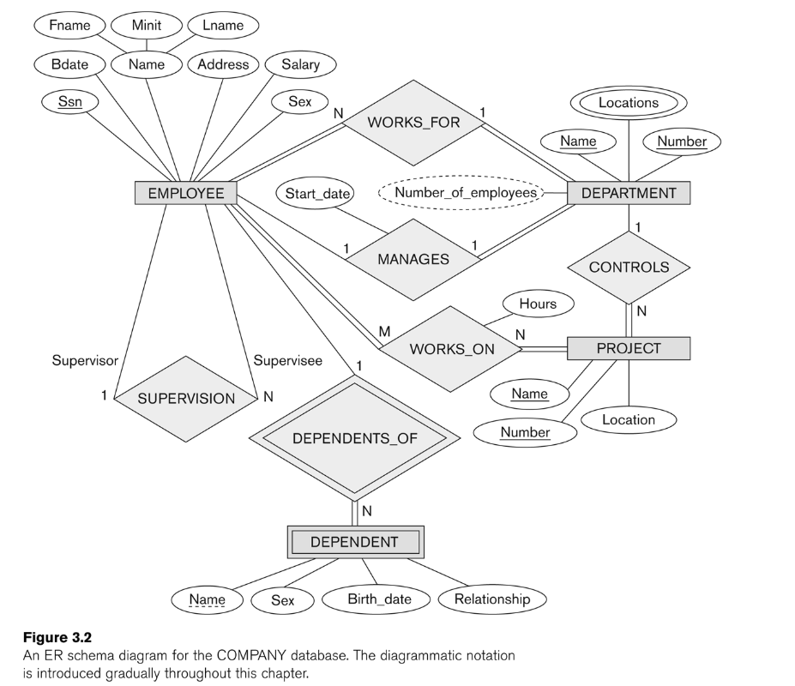

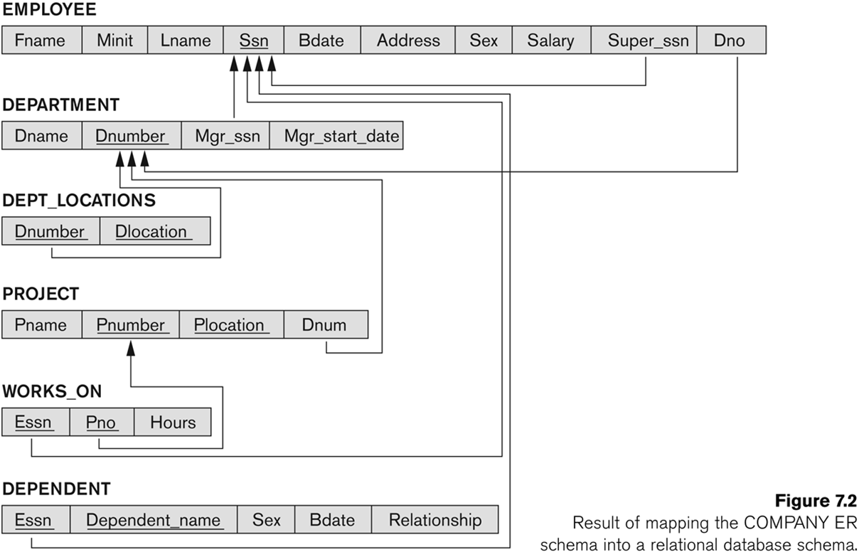
- Mapping of Union Types (Categories).
  - For mapping a category whose defining superclass have different keys, it is customary to specify a new key attribute, called a surrogate key, when creating a relation to correspond to the category.
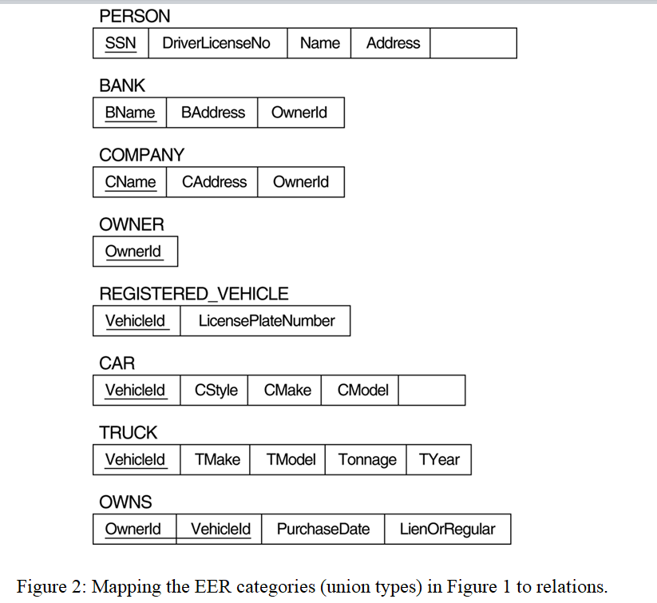
  - In the example below, create a relation OWNER to correspond to the OWNER category and include any attributes of the category in this relation. The primary key of the OWNER relation is the surrogate key, which we called OwnerId.

Case Study considered for Database Design:

The problem revolves around designing a database for a Hospital Management System. It manages patient details, doctor information, department allocations, hospital bed assignments, appointment scheduling, medical records, prescriptions, and billing details, while maintaining essential constraints, specializations, generalizations, and relationships to ensure accurate and efficient management of hospital operations.

EER model for case study:

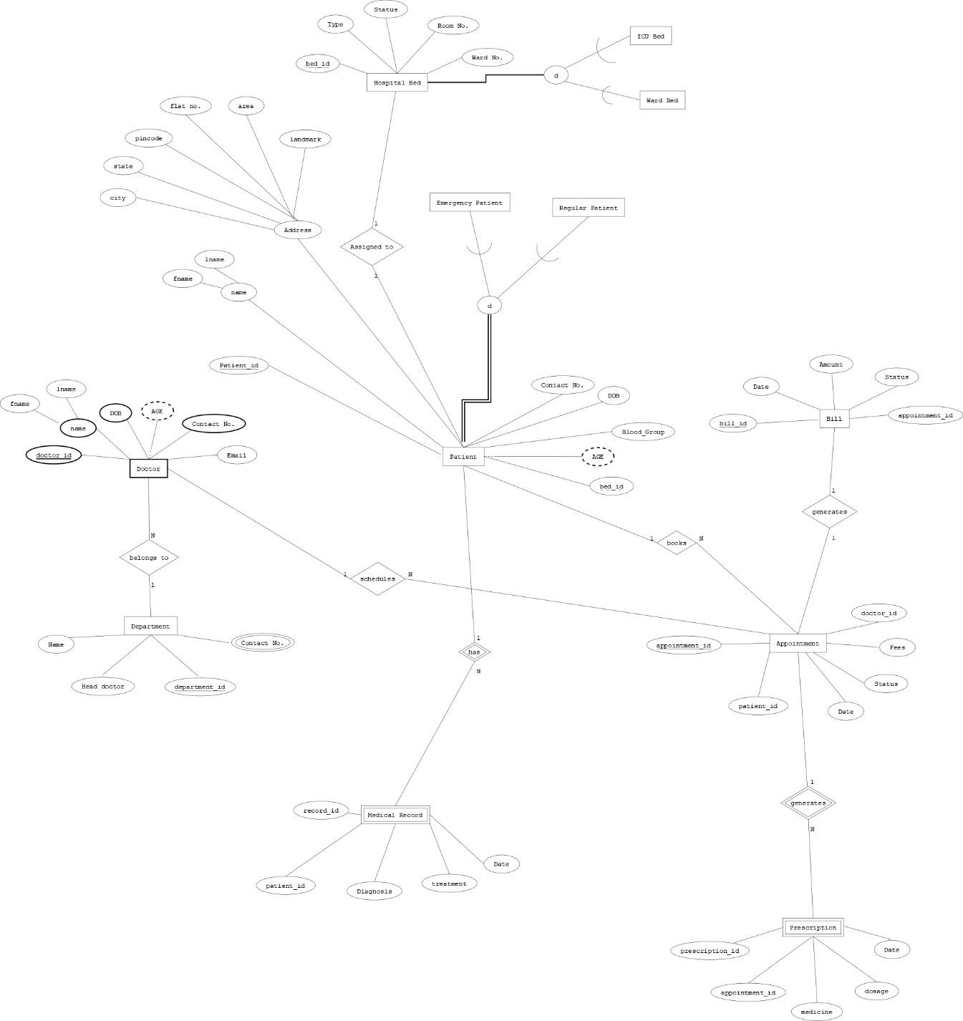

Relational Model of case study :

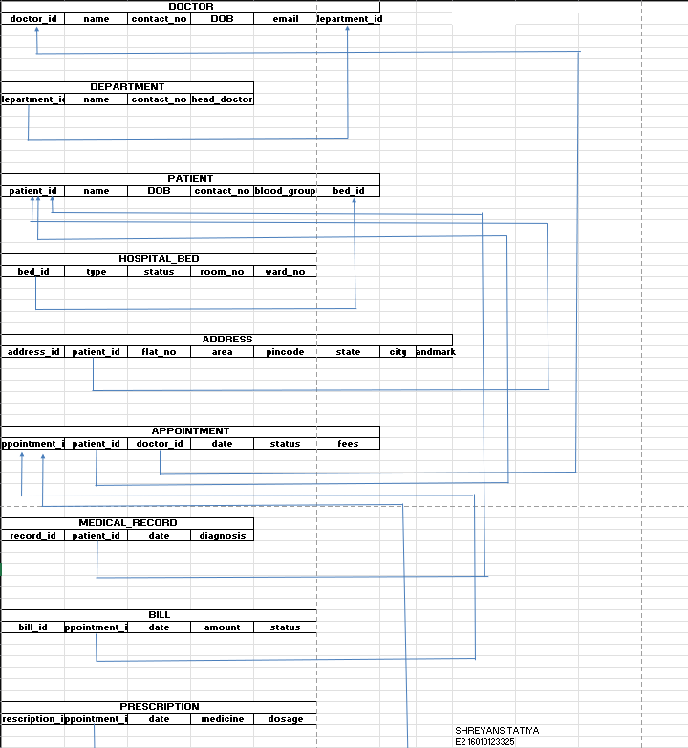

Conclusion :

The above experiment showcases designing of EER diagram and creating the respective Relational model for the case study ie Hospital Management System.

Post Lab Descriptive Questions

- In the Academic database a Grade is issued to each STUDENT for each COURSE taken and stored in the STUDENT COURSE DETAIL entity. A STUDENT may decide to re-take a COURSE to better their GRADE. The administration would like to keep a record of the old/previous Grade as well as the new Grade. Show ER diagram to include historical Grades if the students should have them.

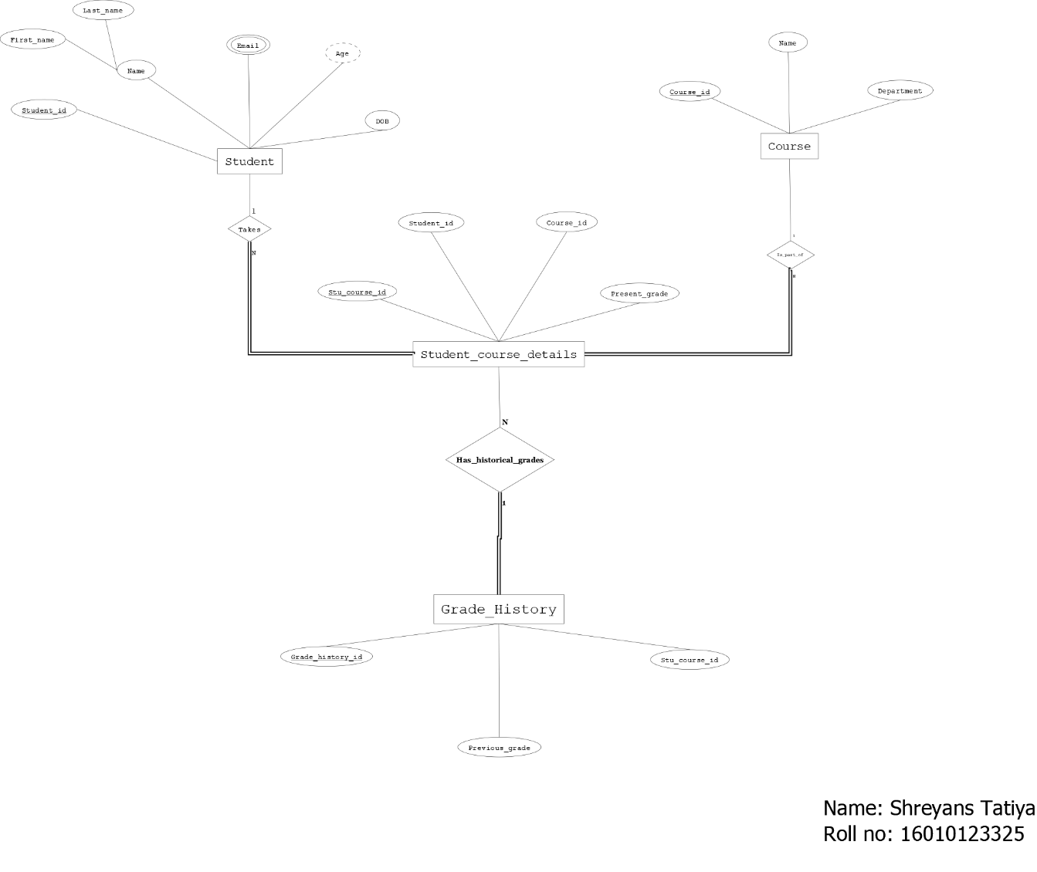

- Discuss the concept of aggregation. Give an example. How to represent aggregation in ER model (if aggregation is not supported in EER diagram).

Aggregation represents a relationship as an abstract entity that participates in another relationship. It is used when a relationship itself needs to have attributes or relate to additional entities.

Example-
Here the Employee, Project and Department are related by the ‘Works On’ relation which acts as a one single entity and relates to the Manager.

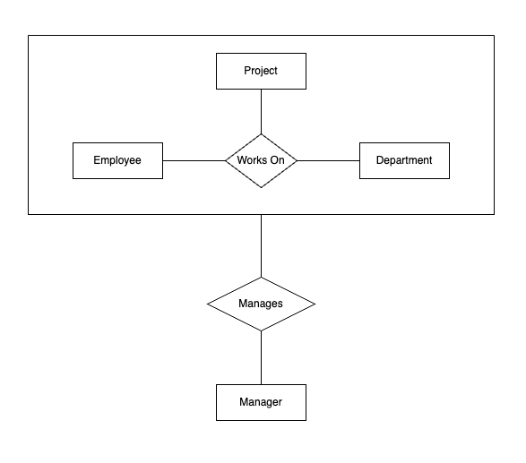

If Aggregation is not supported in EER

